JS/HTML

- Username page
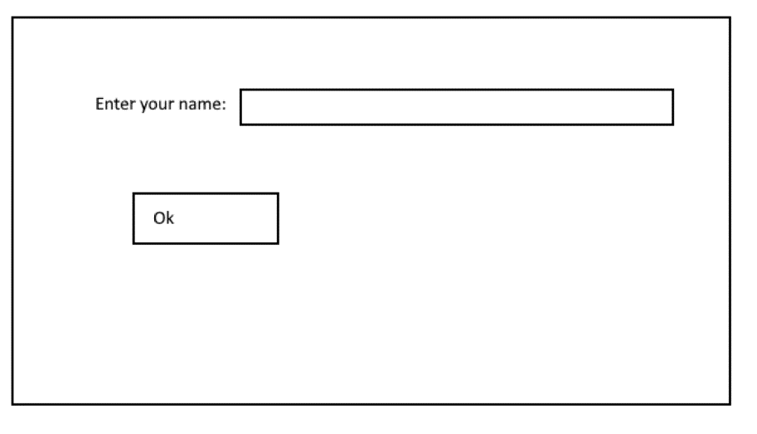
- Arena
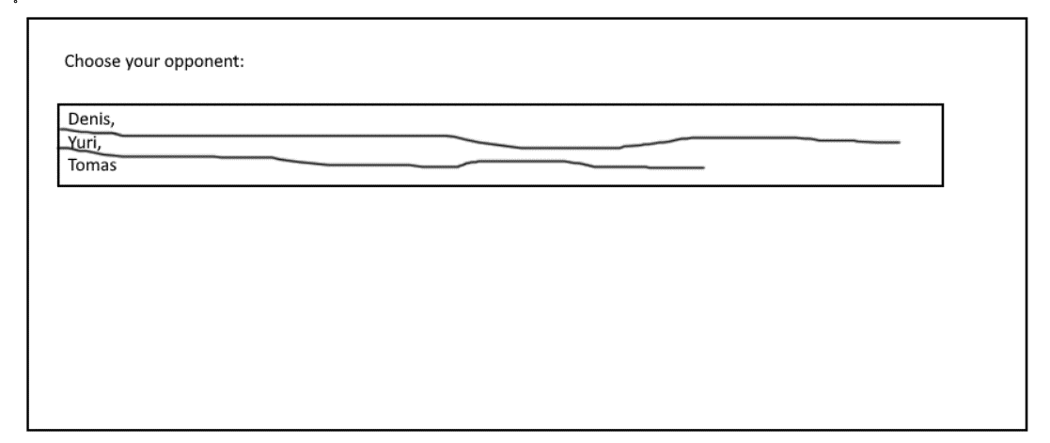
- BattleField
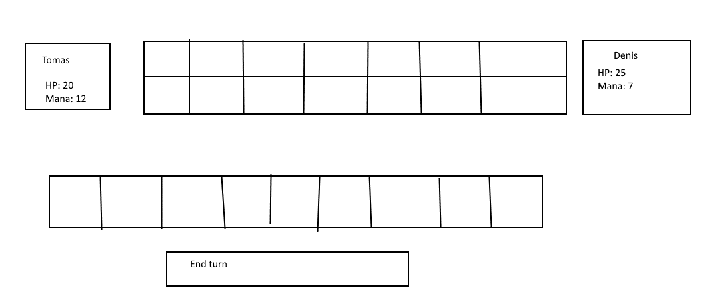
- Create classes:
- User.
- Name,
- HP
- Mana
- Card
- Id
- Name
- Description
- Img Url
- Hp
- Attack
- Mana cost
- Battle – represents battle:
2 User objects
2 arrays of Card
Method ‘Calculate turn’: calculate damage, remove ‘died’ cards, add new card. Calculated players health, mana points.

Turn calculation:

- Recalculate player’s mana
- All user’s card’s deal damage to opponents cards.
If opponent’s HP after damage 0 or less – remove them.
If card doesn’t have opponent – damage deals to Player’s HP.
- If player’s HP 0 or less – END GAME!
- Put a new card on battlefield

